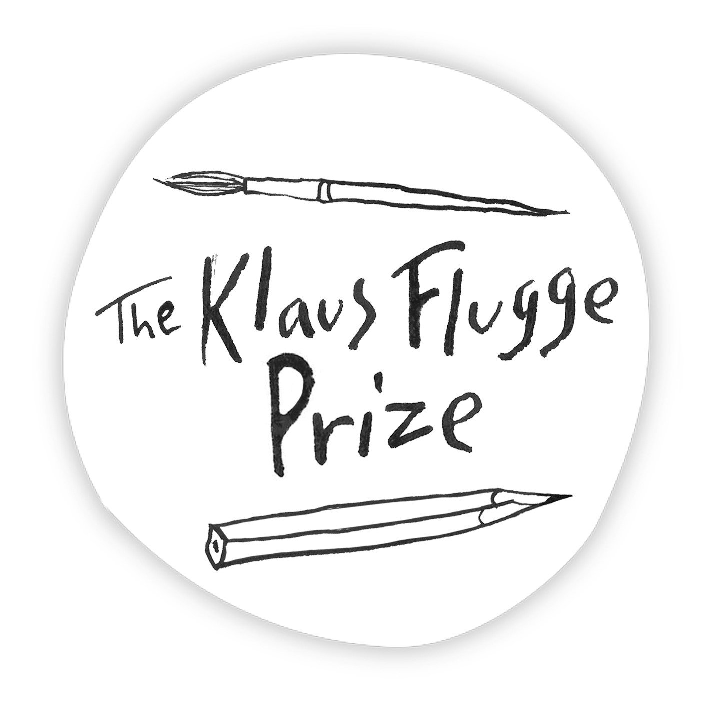
Administrator: Andrea Reece
Tel: 07807893369 Email andrea.reece@zen.co.uk

Criteria for 2020 Award

- The Award will be made annually to the most promising and exciting newcomer to children’s book illustration in a single calendar year.
- The illustrator may have may have created book covers, or illustrations for other media, or illustrated books in another genre - for example, poetry or in fiction - but eligibility for the prize requires that this is her or his first picture book for children.
- The Award will be for a picture book for children, i.e. a book for children in which the illustrations are as or more important than the words in telling the story; a book with illustrations on every page or on one of every pair of facing pages.
- The book should have been first published on a children’s list in the UK between 1 January and 31 December 2019. Books first published in another country must have been co-published in the UK within three months of the original publication date.
- The book must have an Editor.
- We cannot accept books that are only available in e-format or that are self published or where the author has contributed or paid for the costs of publishing.
- The winning illustrator will receive a cheque for £5,000.

Rules of entry for 2020 Award

- Publishers should ensure that all submissions satisfy the criteria given above.
- Each publisher may submit books from any of their imprints.
- The publisher should initially submit 2 copies of each book - one for the Chair of Judges, Julia Eccleshare, one for the Administrator and Publicity Manager, Andrea Reece Please send the book(s) for consideration direct, complete with the submission form(s), to the addresses below.
- We would also request extra copies, once a title has been shortlisted, for publicity purposes
- Shortlisted illustrators are expected to attend the award ceremony in London on the evening of 16 September 2020.
- All correspondence should be with the Administrator only.

Please send one copy of each submission to:
Julia Eccleshare, 37 Oak Village, London NW5 4QN
and

Andrea Reece, 30 Winton Avenue, London N11 2AT

Closing date for submissions: 30 December 2019
PLEASE MARK PARCELS: THE KLAUS FLUGGE PRIZE SUBMISSION

