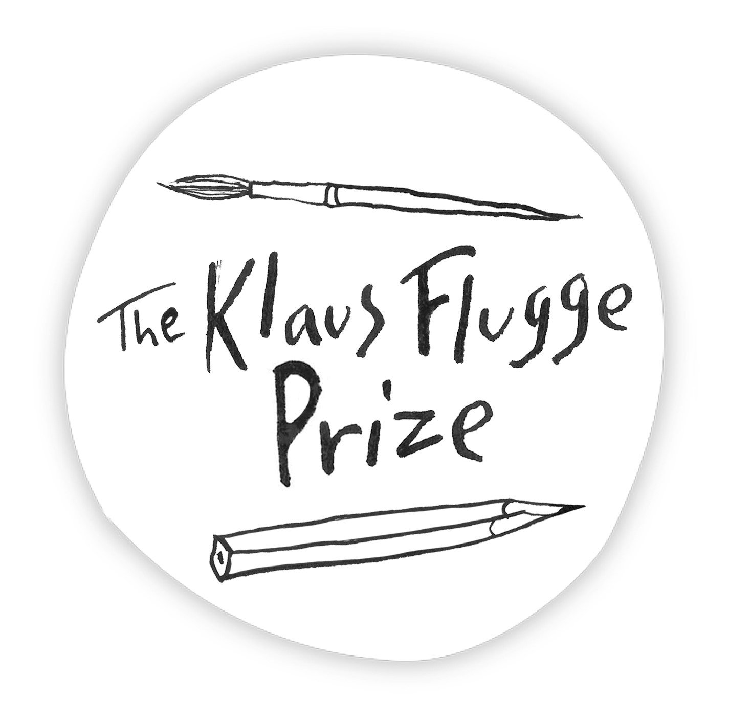
Administrator: Andrea Reece
Tel: 07807893369 Email andrea.reece@zen.co.uk

Submission form 2023

Please complete one form for each title which you submit for consideration for the Award. Submissions, each accompanied by a correctly completed form, should be submitted, together with the books on or before 10 January 2023
Please see Criteria for 2023 sheet for where to send books.

Title of book:

Name of illustrator:

Name of publishers:

Name of imprint (where appropriate):
Publication date:

Name of editor:

Name of Art Director/designer:

Short illustrator profile:

I confirm that this book is a first picture book for children by this illustrator.

Signature: …………………… Name (please print)………………………………….….

Position in company: ……………………………………………………………………….…..

Direct line: …………………………… E-mail: ………………………………………………

If you have any queries, please contact Andrea Reece 07807893369
email andrea.reece@zen.co.uk

